# HydroDesktop 1.3 New Feature Specifications

Jiří Kadlec, Daniel Ames 18th October 2011

## Search User Interface

The search user interface is moved to the main ribbon toolbar. The following search parameters can be selected:

* WHERE (Select area – select rectangle, select polygons, or select by attribute)
* WHAT (Select keywords)
* WHEN (Select date range)
* WHO (Select data sources)

The **Run Search** button starts the search

The quick search options are on the search toolbar. Advanced options are shown as dialog windows.

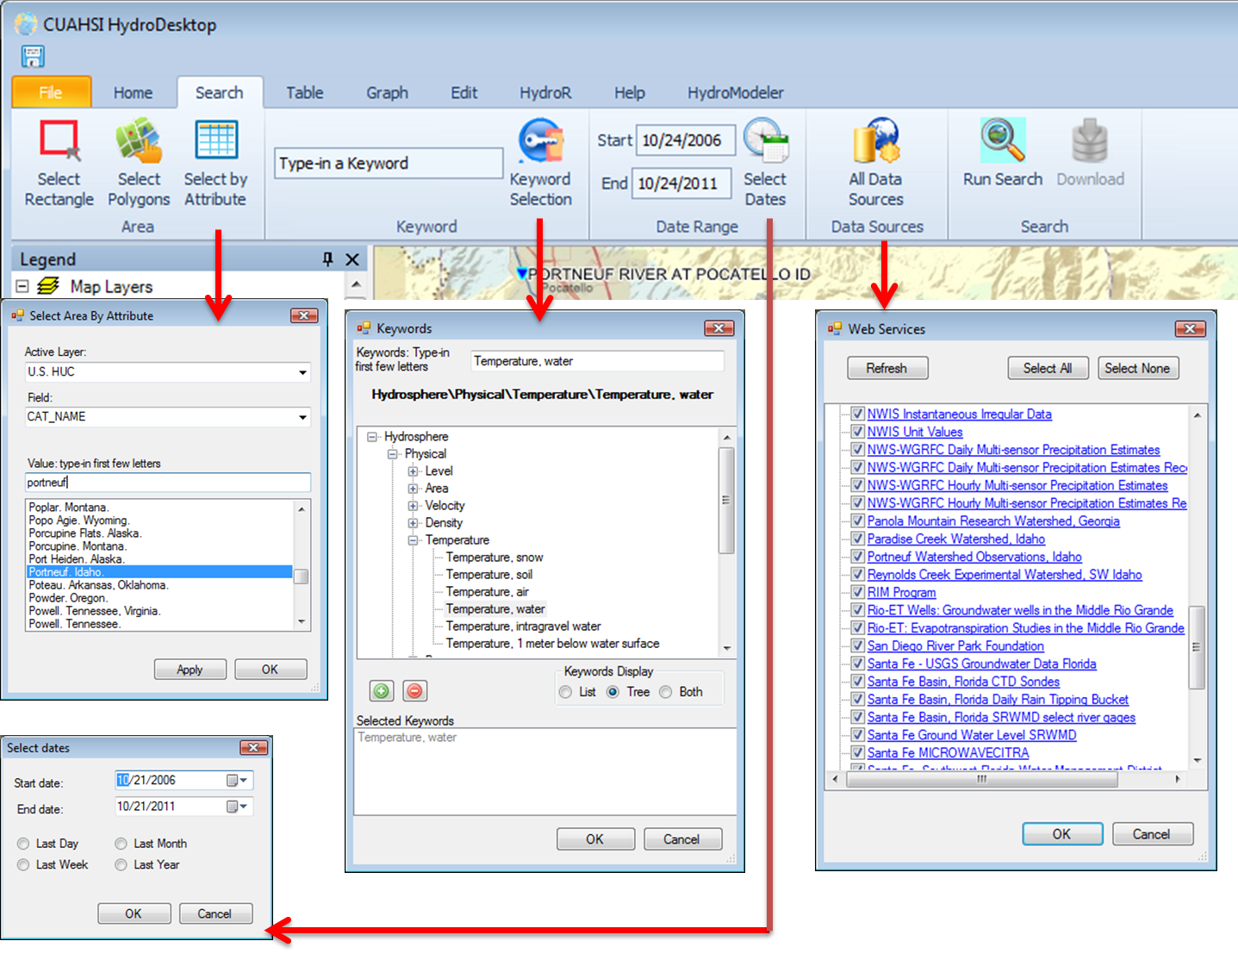

## Filtering Search Results and Downloading Data

Search results are displayed in the map as one or more map layers grouped in a ‘Data Sites’ group. Each layer contains all sites with series that matched the search criteria. When user hovers the map over a site, a pop-up context menu is shown. This context menu contains the data source link, site name, variable names and a ‘Download Data’ link. The size of the symbol is proportional to the value count.

**Map pop-up context menu for a site with multiple time series available at the site**

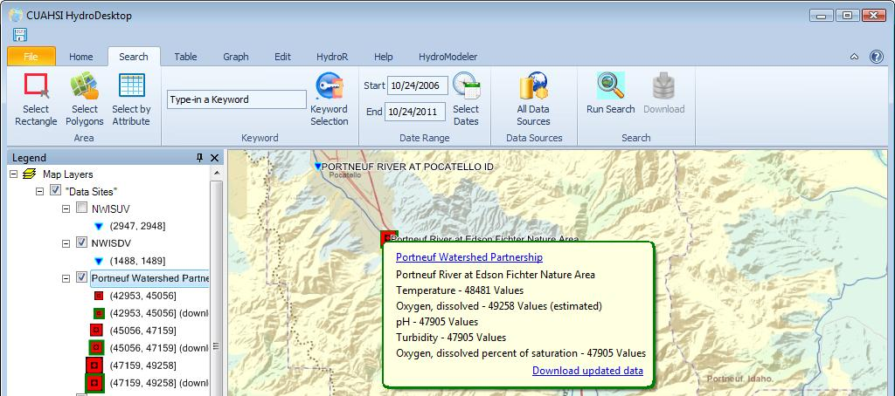

## 2.1 Data Filter (Exploring search results)

The advanced data filter allows to select more sites / series for data download. The data filter replaces the ‘Results’ panel that was in 1.2. The data filter is applied on the search results to narrow down the selection for download. This is used for:

* Filter series by data source
* Filter series by variable
* Filter series by data type (average, maximum, minimum)
* Filter series by value count (number of observation data values)
* Filter series by method
* Filter series by quality control level.

Users can combine the filter options – for example, find sites / series with variable = water temperature, data type = average and value count > 500.

Some advanced filter options are planned:

* Find all sites that measure two variables simultaneously (for example: Find all sites that measure discharge and water temperature at the same site in an overlapping time period)
* Find all sites that are located on the selected river (Select by location functionality, this requires a ‘streams’ or ‘rivers’ map layer that can be obtained by using the EPA Delineation tool)
* Find sites by user-defined query expression

After the data filter is applied, the series are highlighted in the map and users can use the Download button to download all highlighted series.

## 2.2 Showing Downloaded Data in the Map

The same map layer is used to represent the search results and the sites with downloaded time series. The map symbol is used to distinguish sites with downloaded data from sites without downloaded data. If a site has one or more series with downloaded data, then the symbol has a green outline. The mouse-hover popup context menu also has a green outline and has two links : “Update Data Series” and “Show Graph”. The “Show graph” link activates the graph view and shows all series from the site in the graph.

The Data Sites layer also has two context menu items in the legend:

* Show all sites
* Show only sites with downloaded data

## Docking

The purpose of Docking is to enable users to re-arrange the layout of the application on the screen. The screen is divided into several *Dockable Panels*. Users can change the size and position of any dockable panel. A dockable panel can also be dragged and dropped to a separate window (separate screen). One usage of docking is the ability to simultaneously view spatial and temporal data (the “graph” and “map” dockable panels are visible on the same screen) allowing to analyze both the time and space dimension of the data and improving interaction between the map, time series table and graph.

The ISU team is evaluating several options for designing the docking interface. We are aware that docking is an advanced feature. The goal is to enable docking functionality for power-users (such as users with multi-monitor computer screen) and at the same time, keep the main user interface simple to use for other users.

**Key features of the docking interface:**

* Predefined layouts
  + **Default layout** (map, table, graph, edit, HydroR are overlapping and occupy the main screen)
  + **Advanced layout** (the main screen is divided into 3 parts: Map, Table, Graph)
* Reset layout
  + Resets the layout to the default layout
* Saving the layout
  + When users save a project, the dock layout (size and positions of dockable panels) is saved and it is restored when the project is re-opened.

**List of dockable panels in HydroDesktop**

Map, Legend, Time Series selector, table, graph, edit, HydroR, HydroModeler

**Overlapping dockable panels**

The map, table, graph, edit and HydroModeler dockable panels occupy the central portion of the screen in the default layout. Bringing one of the overlapping panels to top is done by clicking the dockable panel caption that is located at the bottom of the main window. We propose that a ribbon tab is only visible if the corresponding dockable panel is visible. For example, it only makes sense to display the “HydroR” ribbon tab toolbar when the user is working with HydroR and when the main HydroR work page is visible.

**Interaction of dockable panels and ribbon tabs**

The dockable panels are linked with corresponding ribbon tabs. For example, the HydroR dockable panel is linked with the HydroR ribbon tab. When the HydroR dockable panel is clicked the HydroR ribbon toolbar tab becomes visible.

*Screenshot of docking – simple layout*

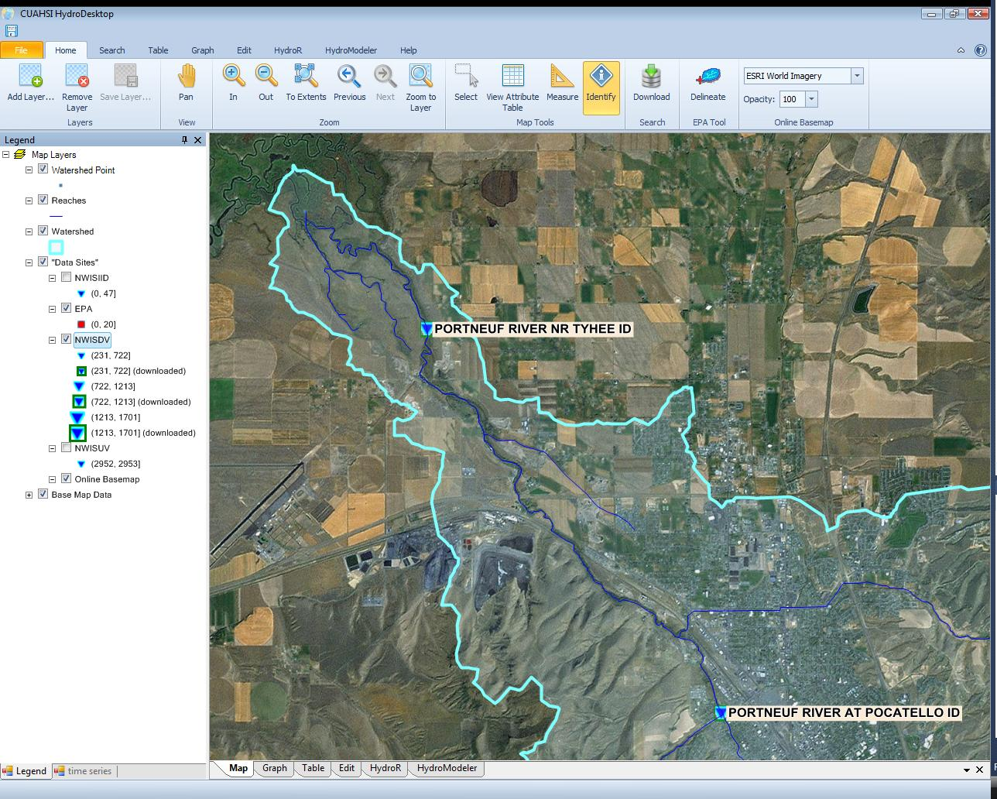

Clicking on the **dockable panel caption** Changes the main view and also selects the corresponding ribbon panel

*Screenshot of docking – Advanced Layout*

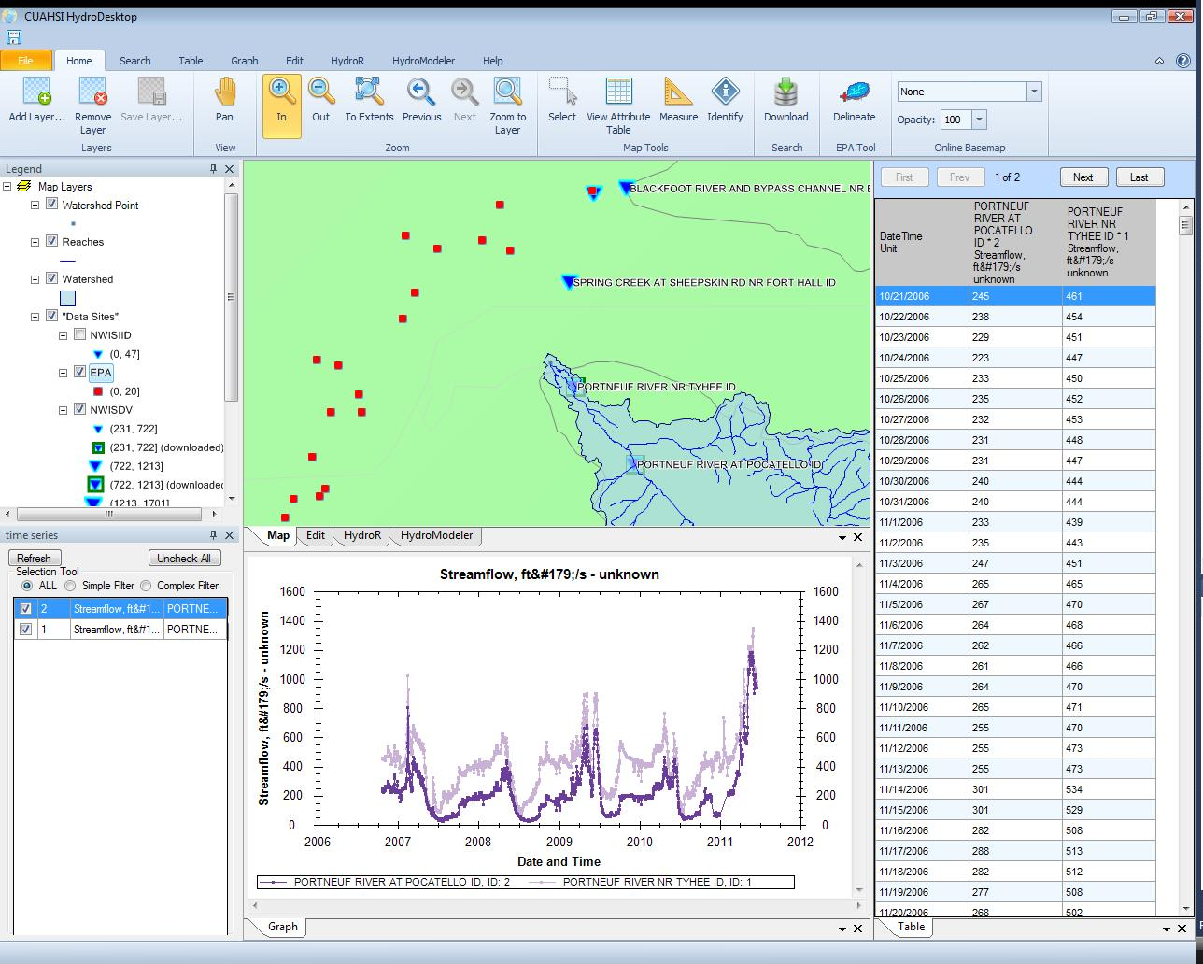

## Other planned functionality for HydroDesktop 1.3

Other planned functionality (doesn’t change the user interface) for version 1.3 is:

* Improved speed and progress reporting of search (we want the search to work for large areas too)
* GIS tools (interpolation, vector – raster conversion, intersect, union, buffer)
* NetCDF multidimensional raster support
* Support for adding user-specified WMS (Web Map Service) and WFS (Web Feature Service) to the map